**CHAPTER-1**

**INRODUCTION**

**1. INTRODUCTION**

The rapid spread of fake news has become a pressing issue in the digital age, influencing public opinion, shaping political narratives, and affecting economic stability. With the widespread use of social media and online news platforms, misinformation now reaches audiences faster than ever, often blurring the lines between fact and fiction. Fake News Growth Analysis is a data-driven study that aims to investigate the patterns, sources, and expansion of misinformation over time. By employing advanced data analytics techniques such as web scraping, statistical analysis, and data visualization, this study seeks to uncover key insights into the dissemination of false information. Through the examination of large datasets, it identifies trends, evaluates engagement metrics across digital platforms, and assesses the broader societal impact of fake news. Furthermore, interactive dashboards and visual reports provide a clearer picture of how misinformation spreads and its far-reaching consequences. The primary objective of this project is to deliver actionable insights that can help detect, analyze, and mitigate the influence of fake news, ensuring that reliable and accurate information prevails in today’s digital landscape.

**1.1. INTRODUCTION TO THE PROJECT**

In today’s interconnected world, the uncontrolled spread of misleading information has become a pressing concern, influencing public opinion, shaping political ideologies, and disrupting economic stability. The rise of digital platforms, including social media, online news websites, and messaging applications, has accelerated the dissemination of deceptive content, making it increasingly difficult to differentiate between factual and manipulated information. Unlike traditional journalism, where content undergoes rigorous verification, digital media enables unfiltered stories to circulate widely, often gaining traction before their authenticity is verified. This widespread misinformation has led to public confusion, political manipulation, and financial instability, fueling ideological conflicts and deepening distrust in mainstream media. To address this growing issue, the **Fake News Growth Analysis** project employs advanced data analytics techniques to study the evolution, sources, and impact of fake news. Various tools such as Python, web scraping frameworks (Beautiful Soup, Scrapy), and data analysis libraries (Pandas, NumPy) are used to collect, process, and analyze misinformation trends. Visualization tools like Matplotlib, Seaborn, and Power BI provide graphical insights, helping to track engagement metrics and assess the reach of false information. Additionally, sentiment analysis tools such as NLTK, TextBlob, and VADER are leveraged to understand audience reactions to fake news content. By utilizing these data-driven methodologies, the project aims to uncover key patterns in misinformation dissemination and provide actionable insights for researchers, policymakers, and media organizations. The ultimate goal is to support the development of automated detection systems, enhance fact-checking mechanisms, and promote media literacy to ensure that credible and accurate information prevails in the digital era.

**1.2 Objective of Project**

The Fake News Growth Analysis project aims to investigate the rapid spread of misinformation across digital platforms and its influence on public perception, politics, and economic stability. With the increasing reliance on online news and social media, identifying and mitigating fake news has become a critical challenge. This project seeks to analyze the origins, patterns, and factors contributing to the proliferation of false information, offering data-driven insights to combat its impact.

To achieve this, the project leverages data analytics tools such as web scraping(BeautifulSoup, Scrapy) for data collection, data processing libraries (Pandas, NumPy) for structuring and cleaning datasets, and Natural Language Processing (NLP) techniques (NLTK, TextBlob) for sentiment analysis. Data visualization tools (Power BI, Tableau, Matplotlib**,** Seaborn**)** are used to track trends and engagement metrics, while machine learning models (Scikit-learn,Tensor Flow) aid in classifying and detecting misleading content.

Beyond technical analysis, the project emphasizes media literacy, digital awareness, andfact-checking initiatives to curb the influence of fake news. By equipping researchers,policymakers, and media organizations with actionable insights, this study aims to develop effective strategies for misinformation detection, enhance fact-verification methods, and promote the responsible dissemination of accurate information in the digital ecosystem.

**Feature of Project**

The **Fake News Growth Analysis** project is designed to detect, analyze, and visualize the spread of misinformation using advanced data analytics. It leverages machine learning, NLP, and data visualization tools to provide insights into how fake news propagates. The project also includes real-time monitoring, predictive analysis, and interactive reporting to combat misinformation effectively.

**1**. **Automated Web Scraping:** Collects news articles and social media data using BeautifulSoup and Scrapy to build a dataset for analysis.

**2. Data Cleaning & Pre-processing:** Uses Pandas and NumPy to filter, structure, and clean raw datasets for better accuracy.

**3. Natural Language Processing (NLP):** Analyses sentiment, tone, and authenticity of news using NLTK, TextBlob to detect misleading content.

**4. Machine Learning-Based Detection:** Implements Scikit-learn and TensorFlow for fake news classification and predictive analysis.

**5. Real-Time Monitoring:** Tracks the spread of misinformation across various online platforms in real time.

**6. Data Visualization & Reporting:** Generates insightful and interactive dashboards using Power BI, Tableau, Matplotlib, and Seaborn.

**7. Trend & Pattern Analysis:** Identifies key trends, sources, and factors contributing to the virality of misinformation.

**8. Sentiment & Engagement Analysis:** Measures audience reactions and engagement with fake news articles and posts.

**9. Fact-Checking & Verification Support:** Assists media organizations with automated tools to verify content authenticity and credibility.

**1.3. Advantages of Project**

**1.** Extracts news articles and social media posts using automated web scraping for large-scale data collection.

**2.** Analyzes text patterns, sentiment, and authenticity using advanced NLP techniques.

**3.** Utilizes machine learning models to classify and predict fake news with high accuracy.

**4.** Tracks misinformation trends in real time to understand its spread and influence.

**5**. Generates interactive dashboards and visual reports to highlight key insights.

**6**. Supports fact-checking initiatives by identifying and verifying suspicious news content

**1.4. Scope of project**

This project doesn’t just aim to detect fake news—it explores how fake news grows, spreads, and impacts people across digital platforms. It studies how a single false article or post can turn into a viral chain, using real-time data analytics to uncover patterns behind this growth.

With tools like BeautifulSoup and Scrapy, the system collects data from news websites and social media. This raw data is cleaned and structured using Pandas and NumPy, then analyzed using sentiment analysis tools like TextBlob, NLTK, and VADER to understand emotional tone—since emotionally charged content spreads faster and wider.

What makes this project unique is its use of machine learning to detect not just fake content, but also why certain types of fake news go viral. It identifies key traits that drive engagement and spread. The results are shown through interactive dashboards made with Power BI, Tableau, and Python libraries like Matplotlib and Seaborn, making trends and insights easy to visualize.

Most importantly, this project fills an important gap by raising awareness. It gives researchers, educators, and journalists tools to understand and fight misinformation more effectively. In the future, it could support real-time fact-checking, early fake news alerts, and more informed digital media use.

**CHAPTER - 2**

**SYSTEM STUDY AND ANALYSIS**

The Fake News Growth Analysis project focuses on understanding how misinformation spreads across digital platforms using data analytics. It begins with automated data collection through tools like BeautifulSoup and Scrapy, gathering content from news websites and social media. This raw data is cleaned and structured using Pandas and NumPy, making it suitable for analysis. The system applies exploratory data analysis (EDA) to discover trends, such as peak times of fake news spread, viral content patterns, and frequently used keywords or sources.

To gain deeper insights, the project integrates sentiment analysis using NLP tools like TextBlob, NLTK revealing how emotional content influences virality. Machine learning algorithms from Scikit-learn and TensorFlow are used to detect fake news and analyze the behavior behind its spread. Visualization tools such as Power BI, Matplotlib, and Seaborn help present these findings through interactive dashboards and graphs. This system offers a complete pipeline—from data collection to actionable insights—empowering users to detect misinformation patterns and understand their broader impact on society.

**2.1. Feasibility Study**

The Fake News Growth Analysis project is highly feasible due to the availability of open-source tools, large volumes of publicly accessible data, and scalable analytics techniques. Web scraping tools like BeautifulSoup and Scrapy make data collection efficient, while Python libraries such as Pandas, NumPy, and Seaborn enable seamless processing and visualization. With minimal hardware requirements and support from platforms like Power BI and Tableau, the project can be implemented cost-effectively. Its relevance in today's digital age also ensures strong practical value and usability for media agencies, researchers, and policymakers.

1. Economic Feasibility

2. Technical Feasibility

3. Operational Feasibility

4. Legal Feasibility

5. Schedule Feasibility

**2.1.1. Economic Feasibility**

This project is economically feasible as it utilizes free and open-source tools like Python, Pandas, BeautifulSoup, and Matplotlib, minimizing software costs. The system requires no specialized hardware and can be developed on a standard computer setup, keeping infrastructure costs low. Since the focus is on data collection, analysis, and visualization, the return on investment is high in terms of insights and awareness, making it a cost-effective solution for institutions and researchers working to combat fake news.

**2.1.2. Technical Feasibility**

The project is technically feasible as it uses open-source tools like Python, Pandas, BeautifulSoup, and Scikit-learn, which are well-supported and easy to integrate. These tools allow efficient data scraping, processing, sentiment analysis, and machine learning without requiring high-end hardware, making the system cost-effective and practically implementable. The project is both technically viable and practical to implement in a typical academic or organizational setting. It does not demand expensive infrastructure or proprietary software, making it an excellent choice for students, researchers, and institutions aiming to tackle the real-world issue of fake news using data analytics.

**2.1.3. Operational Feasibility**

The Fake News Growth Analysis system is operationally feasible as it meets the practical needs of users like analysts, journalists, and researchers. Its intuitive design, real-time tracking, and interactive dashboards make data insights easily accessible, even to non-technical users. The platform is built to handle large-scale data efficiently and is scalable, ensuring smooth operation as misinformation trends evolve. Overall, it offers a reliable and user-friendly environment to analyze and monitor the spread of fake news effectively.

**2.1.4. Legal Feasibility**

The Fake News Growth Analysis project adheres to all legal and ethical standards regarding data collection, privacy, and digital content usage. It uses publicly available data from credible news sources and social platforms, ensuring no violation of copyright or user confidentiality. The project complies with data protection laws like the GDPR and IT Act by anonymizing user information and avoiding personal data misuse. This legal alignment ensures the project can be safely deployed and used in academic or public sectors without regulatory conflicts.

**2.1.5 Schedule Feasibility**

The project titled "Data Analysis on the Growth of Fake News" is considered to be schedule-feasible. It follows a structured approach that includes understanding the requirements, collecting and preprocessing data, performing analysis, and creating visualizations using tools like Python and Power BI. The availability of datasets and efficient libraries makes the workflow smooth and manageable. While challenges such as large or unstructured data may arise, they can be handled with proper planning and techniques. With consistent effort and a focused approach, the project can be completed successfully within a reasonable period without delays.

**CHAPTER-3**

**DEVEOPMENT ENVIRONMENT**

The development environment for the project is set up to support smooth execution of data analysis, visualization, and basic machine learning. The project is developed using Python with Jupyter Notebook and Visual Studio Code as the primary coding platforms. Python is managed using Anaconda to simplify package installation and maintain a stable environment. For data preprocessing, libraries like Pandas, NumPy, and Regex are used, while Matplotlib, Seaborn, and WordCloud help in visualizing trends and patterns. Basic machine learning is implemented using Scikit-learn to detect fake news by training a simple model on text data converted through TfidfVectorizer. Power BI is used to create interactive dashboards for better presentation of the results. If needed, data is collected through web scraping using tools like Requests and BeautifulSoup. Git and GitHub are used for version control and collaboration. This environment ensures an efficient workflow from data handling to final visualization and reporting.

**3.1. Hardware Requirements**

Hardware requirements refer to the physical components and specifications a computer system must have to effectively run and support a particular application or software, including aspects like processor speed, memory (RAM), storage capacity, and peripheral devices

Processor: Intel i5 or above

Processor Speed: 2.00 GHz or higher

RAM: 4 GB or above (8GB recommended)

Hard disk utilization: 50 GB or more (for development purpose)

**3.2. Software Requirements**

Software requirements refer to the specific programs, operating systems, and frameworks needed for an application to function correctly. This includes the development environment, libraries, databases, and any additional software dependencies essential for building, testing, and deploying the application.

**1.** **OS**: Windows 10/11

**2**. **Language & Tools**: Python, Jupyter Notebook or VS Code.

**3**. Libraries: Pandas, NumPy, Matplotlib, Seaborn

**4.** Visualization: Power BI Desktop

**3.3 User Side Requirement**

User-side requirements refer to the minimum hardware and software specifications needed on the user's device to effectively access and interact with the application. This includes the necessary browser, internet connection, display capability, and device performance requirements to ensure a smooth user experience.

**3.4. Programming Environment**

Programming environment requirements specify the software tools, libraries, and frameworks needed for developers to build, test, and maintain the application. This includes the coding languages, frameworks, libraries, development platforms, and version control systems that form the foundation for successful application development.

The programming environment for the Fake News Growth Data Analysis project includes essential tools and frameworks for data collection, processing, analysis, and visualization. Python serves as the primary programming language, supported by libraries such as pandas and numpy for data handling, BeautifulSoup and Scrapy for web scraping, and matplotlib, seaborn, and plotly for data visualization. Development is carried out in Jupyter Notebook, VS Code, or PyCharm, while Power BI is used for interactive dashboard creation.

To manage and store data, SQLite or MySQL databases are used, alongside file formats like CSV and JSON. Git and GitHub enable version control and collaboration, ensuring a streamlined development process. For advanced reporting, tools like Streamlit can be integrated to deploy insights as web applications. This comprehensive setup ensures efficient and scalable analysis of fake news growth trends.

**CHAPTER-4**

**SYSTEM DESIGN AND DEVELOPMENT**

**4.1 Introduction**

The system design and development of the project involve several key stages. First, data is collected from reliable fake news datasets or through web scraping if needed. The collected data is then pre-processed using Python libraries like Pandas and NumPy to clean and organize it for analysis. After Preprocessing, exploratory data analysis (EDA) is performed using visualization tools such as Matplotlib, Seaborn, and Word Cloud to identify patterns, trends, and the overall growth of fake news. For detection purposes, basic machine learning models are applied using Sickie-learn to classify news articles as real or fake. Finally, the results and insights are presented using Power BI, which provides interactive dashboards for better understanding. Development is carried out using Jupyter Notebook and Visual Studio Code, offering a flexible and efficient programming environment.

**4.2. System Design**

The system design of the project is focused on a step-by-step process that ensures accurate analysis and detection of fake news using data analytics techniques. The system starts with the **data acquisition stage**, where news articles or datasets are gathered either from publicly available sources or through web scraping. This raw data is then passed to the **data preparation stage,** where it undergoes cleaning, formatting, and transformation to make it suitable for analysis. Once prepared, the data moves to the **analysis layer**, where visual and statistical insights are extracted using tools like Seaborn, Matplotlib, and WordCloud. For identifying fake content, the system uses a basic **machine learning module** built with Scikit-learn, which classifies news articles into real or fake based on patterns in the text. Finally, the **reporting and visualization layer** presents the results in a clear and interactive way using Power BI dashboards. This design helps break down the project into manageable parts, improving efficiency, accuracy, and readability.

**4.3.External Design**

The external design of the project focuses on how the user interacts with the system and views the results. Since this project is mainly based on data analysis and visualization, the output is presented through clear and user-friendly Power BI dashboards. These dashboards display key insights such as fake news trends, category-wise distributions, word clouds, and comparisons between real and fake news over time. The user does not need to interact directly with the backend code; instead, the design ensures that results are shown in a clean and understandable visual format. Charts, graphs, and filters make it easy for users to explore the data. The overall external design prioritizes simplicity, clarity, and effective communication of information, making it accessible even to non-technical users.

**4.4. Physical Design**

The physical design of the project focuses on the actual resources and tools used during development. This project runs on a standard personal computer with basic hardware setup. Python is used as the main programming language along with Jupyter Notebook and VS Code for writing and executing the code. All required Python libraries and tools are installed locally. The dataset is stored in a CSV file format on the system and used for analysis and model building. Visual reports and dashboards are created using Power BI Desktop, which is also installed on the same system. The entire system is designed to work offline after the initial setup, using local storage and tools for smooth development and testing.

**4.5. Element of Design**

Elements of Design refer to the key components that define how the system will be structured and function. These elements provide a blueprint for the system’s architecture, components, data flow, and user interface.

Elements of design in data analysis define the key components that structure the data pipeline, ensuring efficient processing, interpretation, and visualization. These elements create a blueprint for how data is collected, cleaned, analyzed, and presented, ensuring accuracy and meaningful insights.

Key design elements include:

**1. Data Acquisition & Collection** – Defines methods for gathering structured and unstructured data from sources like databases, APIs, web scraping, or real-time streams.

**2. Data Preprocessing & Cleaning** – Involves handling missing values, removing duplicates, normalizing data, and ensuring data integrity for accurate analysis.

**3. Exploratory Data Analysis (EDA)** – Uses statistical and visualization techniques to uncover patterns, trends, and correlations within the dataset.

**4. Data Modeling & Interpretation** – Applies analytical techniques, including statistical modeling, classification, clustering, or trend analysis, to derive insights.

**5. Visualization & Reporting** – Uses tools like Power BI, Tableau, Matplotlib, and Seaborn to present findings in an understandable and interactive format.

**6. Scalability & Performance Optimization** – Ensures efficient handling of large datasets using optimized queries, parallel processing, or cloud-based analytics.

**4.6. Process Design**

The process design of the project includes a few clear steps. First, fake news data is collected from online sources or downloaded as a dataset. Then, the data is cleaned and prepared using Python so it’s ready for analysis. After that, visual analysis is done using charts and graphs to understand how fake news is growing. A basic machine learning model is used to detect whether news is real or fake. Finally, the results are shown using Power BI in the form of dashboards and visual reports.

Once the data is prepared, visual analysis is performed using charts and graphs to identify trends in fake news growth. If needed, a simple machine learning model can be applied to classify news as real or fake. Finally, the results are presented using Power BI through interactive dashboards and reports, making it easy to understand and interpret insights. This step-by-step approach ensures accurate and meaningful analysis of fake news trends.

Visualization plays a key role in understanding the patterns and spread of fake news. It helps transform complex datasets into clear, meaningful insights through charts, graphs, and interactive dashboards. By using tools like Power BI, Tableau, Matplotlib, and Seaborn, different aspects of fake news growth can be analyzed effectively.

Common visualization techniques include line charts to track fake news trends over time, bar graphs to compare sources spreading misinformation, heat maps to show correlations, and geospatial maps to analyze the regional spread of fake news. Interactive dashboards allow users to filter and explore data dynamically, making it easier to identify key insights. Effective visualization not only simplifies data interpretation but also supports better decision-making in tackling misinformation.

By using tools like **Power BI, Tableau, Matplotlib, and Seaborn**, analysts can track **how fake news spreads over time, which platforms contribute most to misinformation, and regional trends in its growth.** Visualization also helps in detecting anomalies, understanding audience engagement, and making data-driven decisions. It improves communication by presenting insights in a way that is easy to interpret, ensuring stakeholders can take effective actions to combat misinformation.

`

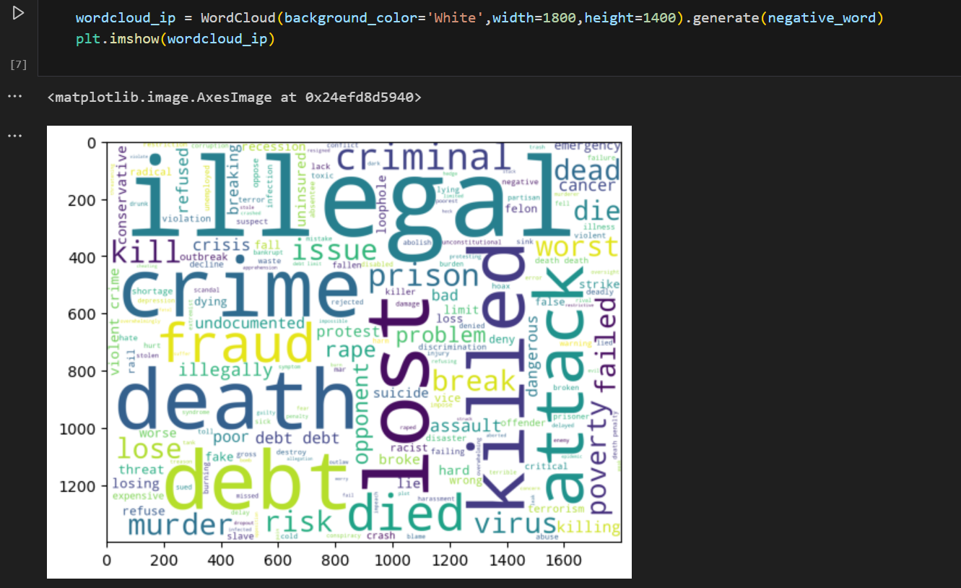

Fig.no.-1.1(Negative word cloud analysis)

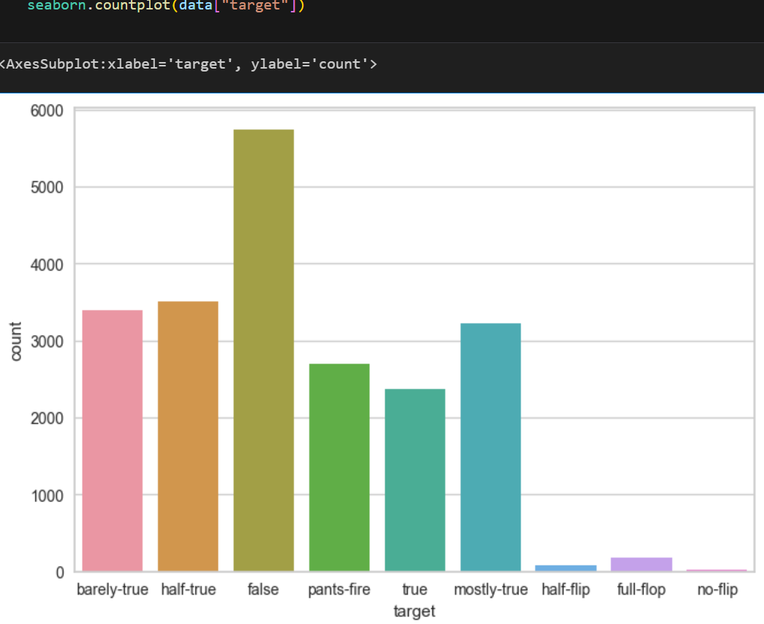Fig.no.-1.2 (Distribution of Truthfulness in News Data)

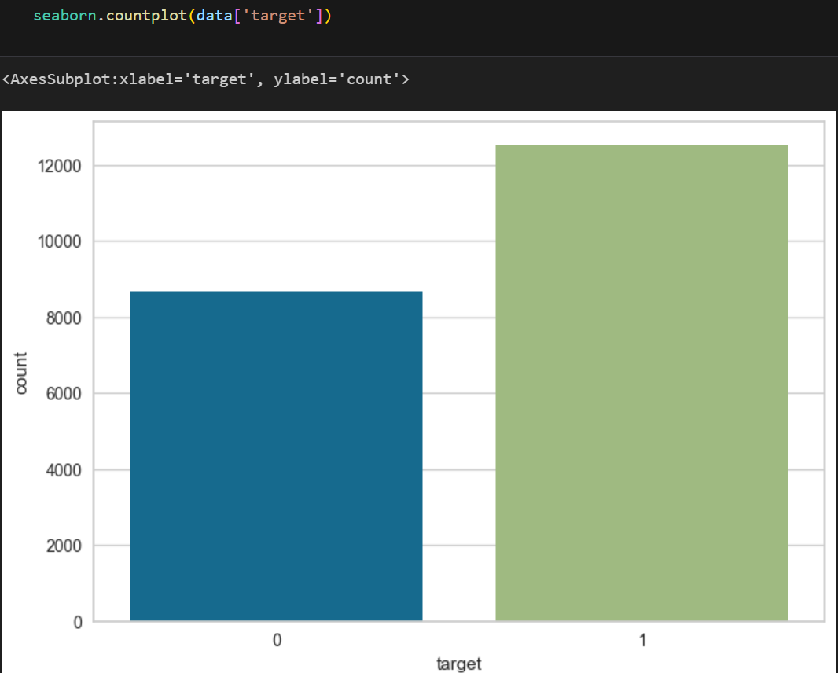 Fig.no. -1.3(Truthfulness Classification of News Articles)

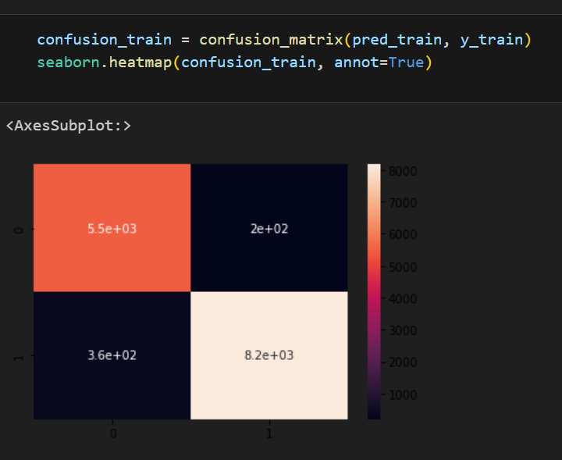Fig.no.-1.4(Confusion Matrix for Fake News Classification)

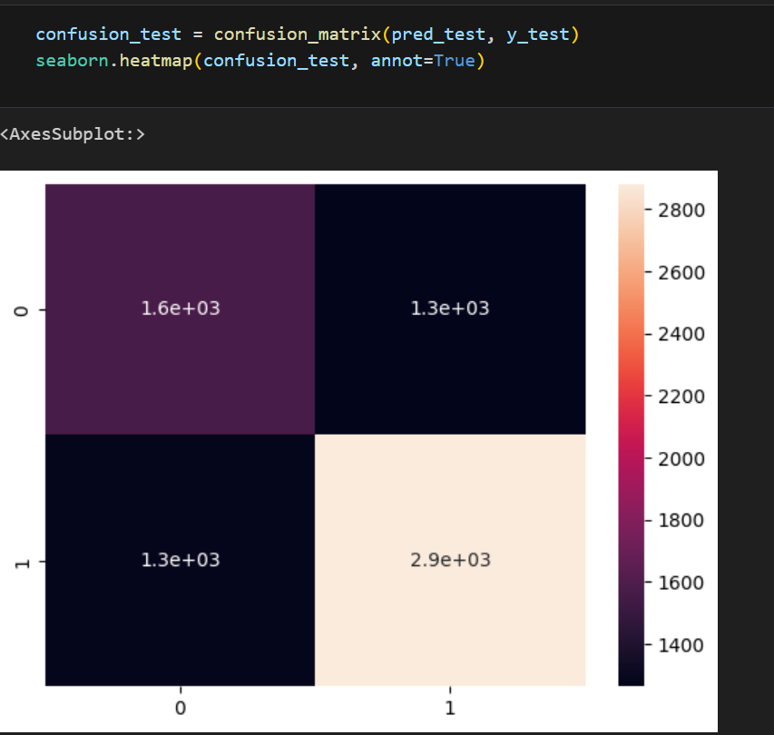Fig.no.-1.5 (Test Data Confusion Matrix)

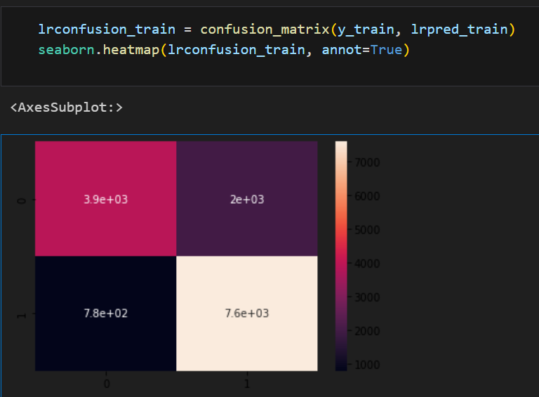

Fig.no.-1.6 (Revealing Misinformation Patterns)

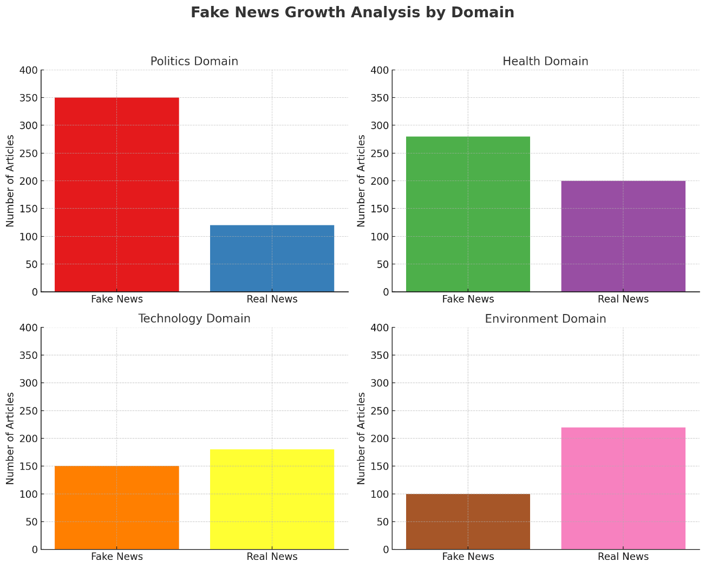Fig.no.-1.7(Different domains news growth)

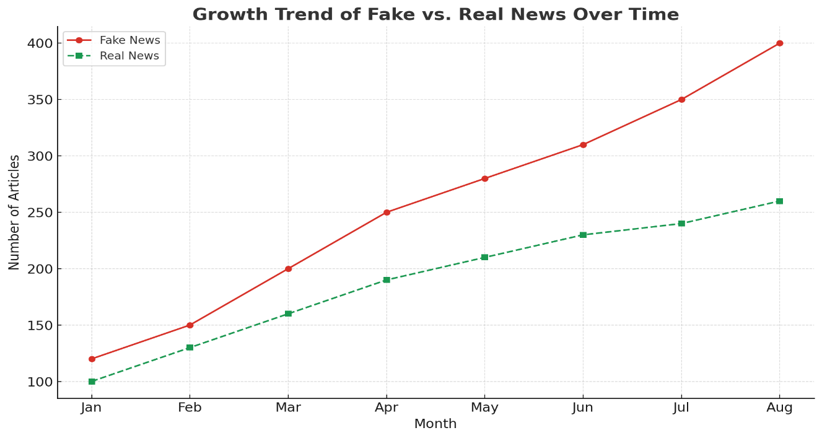

Fig.no.-1.8 (line chart of news over time)



Fig.no.-2.1 (Verify News Authenticity Instantly)



Fig.no.-2.2 (Verify true News content)

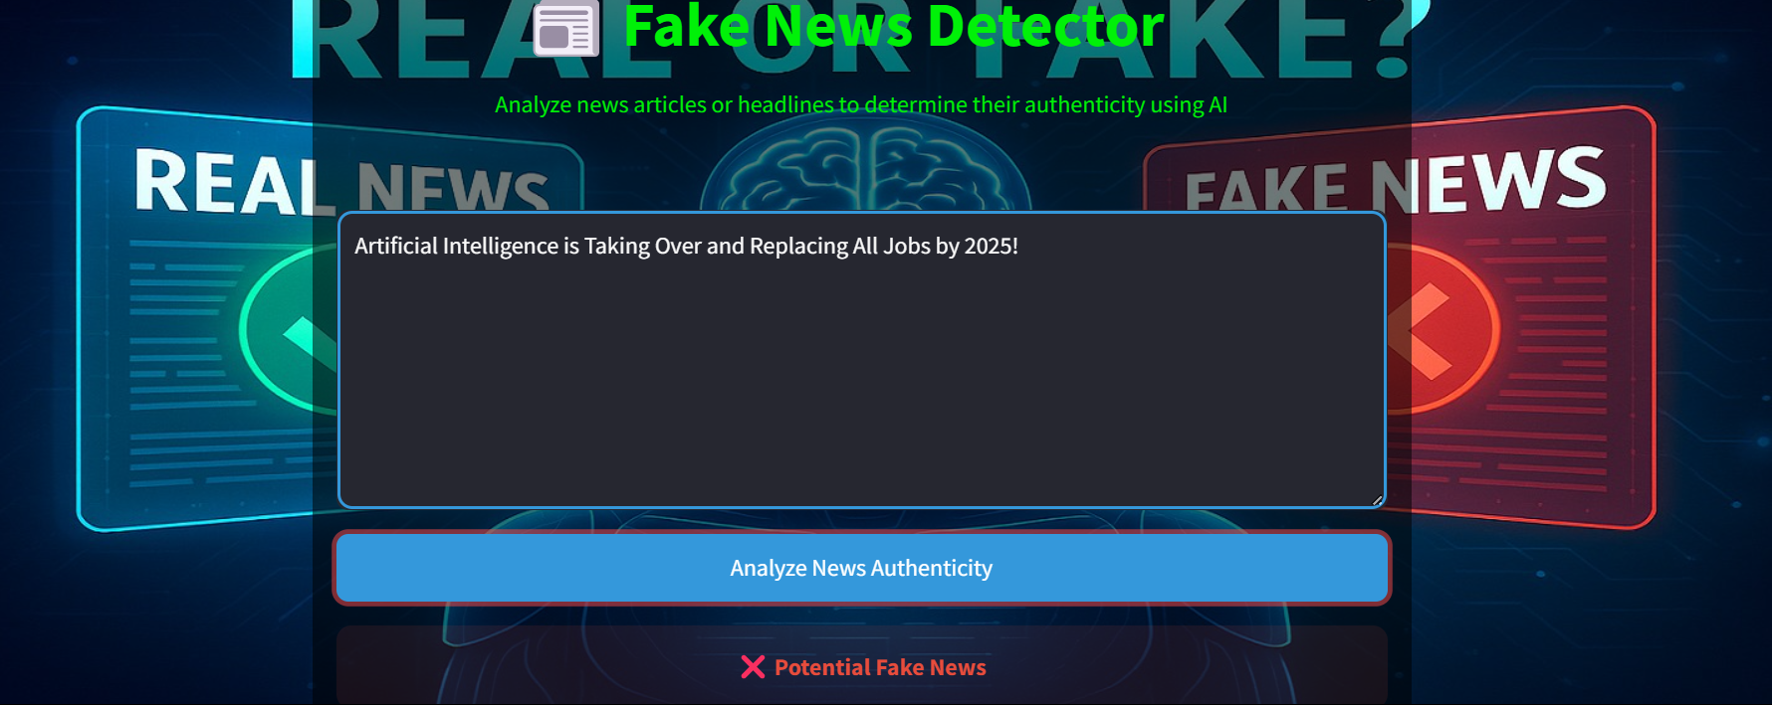

Fig.no.-2.3 (Verify fake News content)